Software Testing Assignment

**Q.1 What Q is SDLC**

**Ans**. SDLC or the Software Development Life Cycle is a process that produces software with the highest quality and lowest cost in the shortest time possible. SDLC provides a well-structured flow of phases that help an organization to quickly produce high-quality software which is well-tested and ready for production use.

**Q.2 What is software testing?**

**Ans.** Software testing is the process of checking the quality of a product before launching. It measures the software&#39;s completeness to the single functional (or non-functional) attributes and whether it has fulfilled the business logic or shown us the missing gaps in requirements that need immediate tackles.

**Q.3 What is agile methodology?**

**Ans.** The Agile methodology is a project management approach that involves breaking the project into phases and emphasizes continuous collaboration and improvement. Teams follow a cycle of planning, executing, and evaluating.

**Q.4 What is SRS**

**Ans.** A software requirements specification (SRS) is a document that describes what the software will do and how it will be expected to perform. It also describes the functionality the product needs to fulfill the needs of all stakeholders (business, users).

**Q.5 What is oops?**

**Ans.** Object-oriented programming (OOP) is a computer programming model that organizes software design around data, or objects, rather than functions and logic. An object can be defined as a data field that has unique attributes and behavior.

**Q.6 Write basic Concept of oops?**

**Ans.** Class. Object. Inheritance. Polymorphism. Encapsulation. Abstration.

**Q.7 What is Object?**

**Ans.** An Object can be defined as an entity that has a state and behavior, or in other words, anything that exists physically in the world is called an object. It can represent a dog, a person, a table, etc.

**Q.8 What is Class?**

**Ans.** Class can be defined as a blueprint of the object. It is basically a collection of objects which act as building blocks.

**Q.9 What is Encapsulation?**

**Ans.** The wrapping up of data and functions together in a single unit is known as encapsulation. It can be achieved by making the data members&#39; scope private and the member function’s scope public to access these data members. Encapsulation makes the data non-accessible to the outside world.

**Q.10 What is Inheritance?**

**Ans.** Inheritance is the process in which two classes have an is-a relationship among each other and objects of one class acquire properties and features of the other class. The class which inherits the features is known as the child class, and the class whose features it inherited is called the parent class. For example, Class Vehicle is the parent class, and Class Bus, Car, and Bike are child classes.

**Q.11 What is polymorphism?**

**Ans.** Polymorphism means many forms. It is the ability to take more than one form. It is a feature that provides a function or an operator with more than one definition. It can be implemented using function overloading, operator overload, function overriding, virtual function.

**Q.12 Draw usecase on online book shopping?**

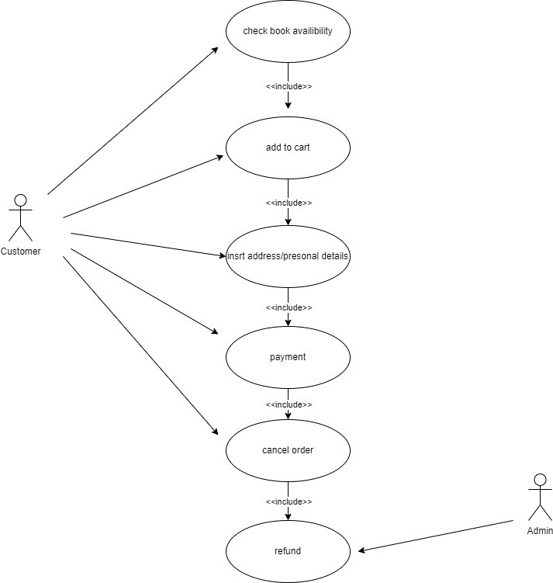

**Q.13 Draw Usecase on Online bill payment System (paytm).**

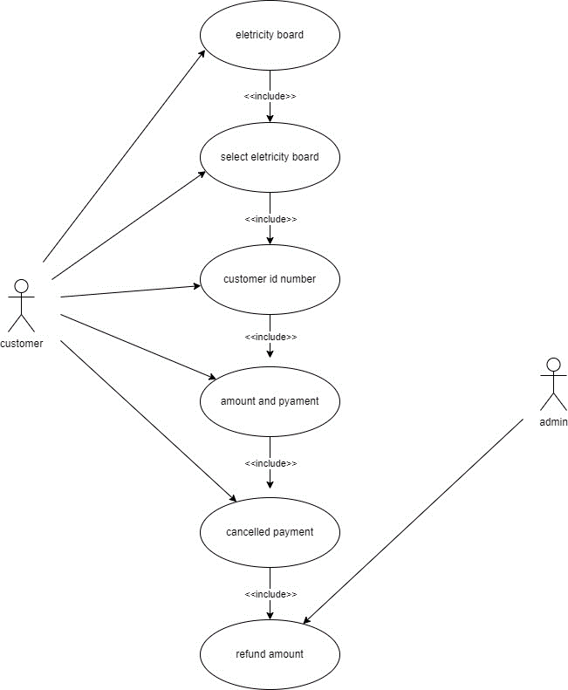

**Q.14 Write SDLC Phases with basic introduction?**

**Ans.1)** Requirment gathering. **2)**Analysis **3)**Design **4)**Implementation **5)**Testing **6)**Maitenance

**1. Requirement gathering:-**

Requirements definitions usually consist of natural language, supplemented by (e.g., UML) diagrams and tables. Three types of problems can arise: **Lack of clarity:** It is hard to write documents that are both precise and easy-to-read. **Requirements confusion:** Functional and Non-functional requirements tend to be intertwined. **Requirements Amalgamation:** Several different requirements may be expressed together.

**2. Analysis:-**

The analysis phase defines the requirements of the system, independent of how these requirements will be accomplished. This phase defines the problem that the customer is trying to solve. The deliverable result at the end of this phase is a requirement document. Ideally, this document states in a clear and precise fashion what is to be built. This analysis represents the “what” phase. The requirement documentaries to capture the requirements from the customer&#39;s perspective by defining goals.

**3.Design:-**

Design Architecture Document Implementation Plan Critical Priority Analysis Performance Analysis Test Plan The Design team can now expand upon the information established in the requirement document. The requirement document must guide this decision process. Analyzing the trade-offs of necessary complexity allows for many things to remain simple which, in turn, will eventually lead to a higher quality product. The architecture team also converts the typical scenarios into a test plan.

**4.implementation:-**

In the implementation phase, the team builds the components either from scratch or by composition. Given the architecture document from the design phase and the requirement document from the analysis phase, the team should build exactly what has been requested, though there is still room for innovation and flexibility. For example, a component may be narrowly designed for this particular system, or the component may be made more general to satisfy a reusability guideline.

**Implementation** - Code Critical Error Removal The implementation phase deals with issues of quality, performance, baselines, libraries, and debugging. The end deliverable is the product itself. There are already many established techniques associated with implementation.

**5. Testing phase:-**

Simply stated, quality is very important. Many companies have not learned that quality is important and deliver more claimed functionality but at a lower quality level. It is much easier to explain to a customer why there is a missing feature than to explain to a customer why the product lacks quality. A customer satisfied with the quality of a product will remain loyal and wait for new functionality in the next version. Quality is a distinguishing attribute of a system indicating the degree of excellence.

**Regression Testing**

**Internal Testing**

**Unit Testing**

**Application Testing**

**Stress Testing**

**6. Maintenance Phase:-**

Software maintenance is one of the activities in software engineering, and is the process of enhancing and optimizing deployed software (software release), as well as fixing defects. Software maintenance is also one of the phases in the System Development Life Cycle (SDLC), as it applies to software development. The maintenance phase is the phase which comes after deployment of the software into the field. The developing organization or team will have some mechanism to document and track defects and deficiencies. configuration and version management reengineering (redesigning and refactoring) updating all analysis, design and user documentation Repeatable, automated tests enable evolution and refactoring.

**Q. 15. Explain phases of waterfall models.**

⇨The sequential phases in Waterfall model are −

**Requirement Gathering and analysis −** All possible requirements of the system to be developed are captured in this phase and documented in a requirement specification document.

**System Design −** The requirement specifications from first phase are studied in this phase and the system design is prepared. This system design helps in specifying hardware and system requirements and helps in defining the overall system architecture.

**Implementation −** With inputs from the system design, the system is first developed in small programs called units, which are integrated in the next phase. Each unit is developed and tested for its functionality, which is referred to as Unit Testing.

**Integration and Testing −** All the units developed in the implementation phase are integrated into a system after testing of each unit. Post integration the entire system is tested for any faults and failures.

**Deployment of system −** Once the functional and non-functional testing is done; the product is deployed in the customer environment or released into the market.

**Maintenance −** There are some issues which come up in the client environment. To fix those issues, patches are released. Also to enhance the product some better versions are released. Maintenance is done to deliver these changes in the customer environment.

**Q. 16. Write phases of spiral model.**

The different phases of spiral model are-

**1. Planning**

This phase begins by gathering  business requirements into a baseline spiral. In the subsequent spiral as the product matures, all system, subsystem  and unit requirements are identified at this stage.  This phase also includes understanding  system requirements through ongoing communication between the customer and  system analysts. At the end of the spiral, the product will be deployed in the identified market. This includes iteration cost, schedule, and resource estimates. This includes understanding  system requirements for ongoing communication between  system analysts and customers.

**2. Risk Analysis**

After the “plan” phase, the team prepares for the “risk” phase. The “risk” phase is designed to take into account the variability in the rate at which a given product might fail. It is designed to account for the uncertainty in the rate at which a given product might fail. During the “risk” phase, the team evaluates various aspects of the current state of the product, such as the state of its code, the state of its design, and the state of its prototype. The team then makes adjustments to the current state of the product based on the changes made in the “plan” phase, and then follows up with a “sales” phase to collect customer feedback. Once  risks are identified, risk mitigation strategies are planned and completed.  Briefly, risk analysis involves identifying, estimating and monitoring  technical feasibility and management risks such as: schedule slippage and cost overrun. After testing the build, at the end of the first iteration, customers rate the software and provide feedback.

**3. Product development**

In the next quadrant, prototypes are built and tested. This step includes architectural design, module design, physical product design and  final design. Convert the proposals made in the first two quadrants  into usable software. This phase also includes the actual implementation of features in a project which are verified by performing testing.

**4. Next phase planning**

In this phase ,the software is evaluated by the customer and feedback is given. The team prepares for the next phase of the planning process. The next phase of the planning process is known as the “spiral” phase. During the “spiral” phase, the team determines the order of events in the current state of the product and then follows these events up with a “revision” phase to “Revise” the current state of the product so that it is ready for production. The “revision” phase is also called the “reproduction” phase, and it is one of the most important aspects of the planning process.

**17. Write agile manifesto principles.**

Our highest priority is to satisfy the customer through early and continuousdelivery of valuable software.

Welcome changing requirements, even late in development. Agile processes harness change for the customer’s competitive advantage.

Deliver working software frequently, from a couple of weeks to a couple of months, with a preference to the shorter timescale.

Business people and developers must work together daily throughout the project.

Build projects around motivated individuals. Give them the environment and support they need, and trust them to get the job done.

The most efficient and effective method of conveying information to and within a development team is face-to-face conversation.

Working software is the primary measure of progress.

Agile processes promote sustainable development. The sponsors, developers, and users should be able to maintain a constant pace indefinitely.

Continuous attention to technical excellence and good design enhances agility.

Simplicity–the art of maximizing the amount of work not done–is essential.

The best architectures, requirements, and designs emerge from self-organizing teams.

At regular intervals, the team reflects on how to become more effective, then tunes and adjusts its behavior accordingly.

**Q. 18. Explain working methodology of agile model and also write pros and cons.**

Agile model believes that every project needs to be handled differently and the existing methods need to be tailored to best suit the project requirements.

In agile the tasks are divided to time boxes (small time frames) to deliver specific features for a release.

Iterative approach is taken and working software build is delivered after each iteration.

Each build is incremental in terms of features; the final build holds all the features required by the customer.

Agile thought process had started early in the software development and started becoming popular with time due to its flexibility and adaptability.

**Crons:-**

Not suitable for handling complex dependencies.

More risk of sustainability, maintainability and extensibility.

An overall plan, an agile leader and agile PM practice is a must without which it will not work.

Strict delivery management dictates the scope, functionality to be delivered, and adjustments to meet the deadlines.

Depends heavily on customer interaction, so if customer is not clear, team can be driven in the wrong direction.

There is very high individual dependency, since there is minimum documentation generated.

Transfer of technology to new team members may be quite challenging due to lack of documentation.

**Prons:-**

Is a very realistic approach to software development Promotes teamwork and cross training.

Functionality can be developed rapidly and demonstrated.

Resource requirements are minimum. Suitable for fixed or changing requirements Delivers early partial working solutions.

Good model for environments that change steadily. Minimal rules, documentation easily employed.

Enables concurrent development and delivery within an overall planned context.

Little or no planning required Easy to manage Gives flexibility to developers.

**Q.19 Draw usecase on Online shopping product using COD.**

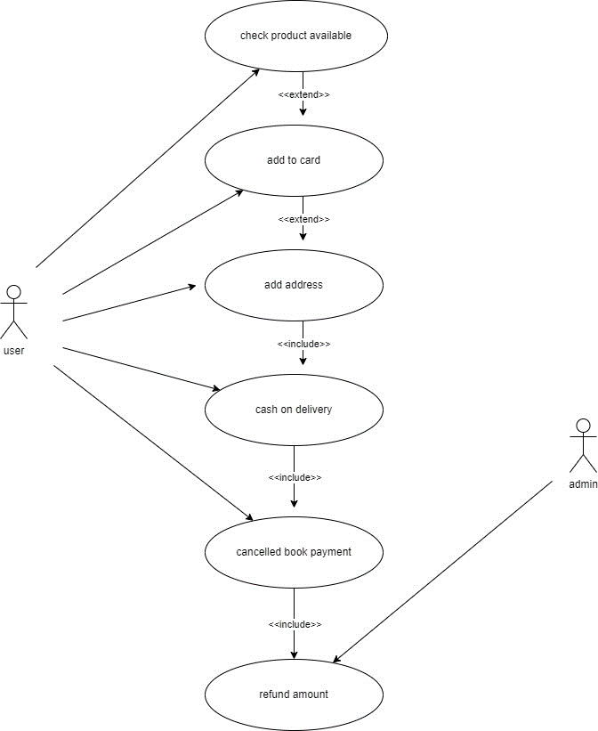

**Q.20 Draw usecase on Online shopping product using payment gateway.**

